Lab title: AI-Assisted Logistics Customer Service
Student name: YASH RUHIL
Roll number: 2620994589
Batch: BBA LSCM
Date: 08/10/2026
AI tool used: CHAT GPT

ROUND 1-

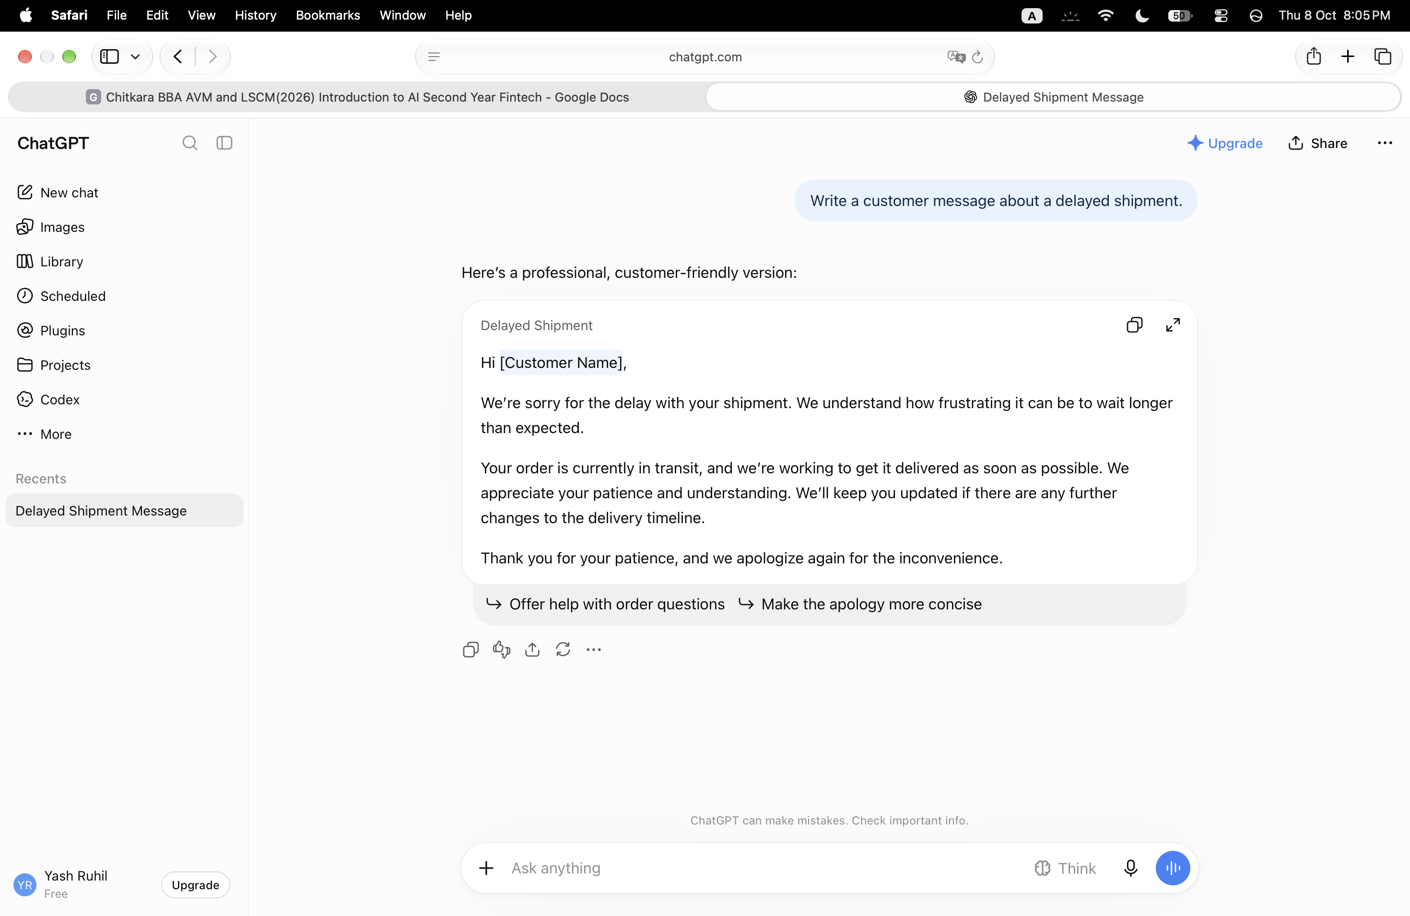
PROMT USED-Write a customer message about a delayed shipment.

1. Observation- The response is professional and customer-friendly, but it is too generic and does not include the specific shipment details required, such as the shipment ID, revised delivery time, or next update.

ROUND 2-

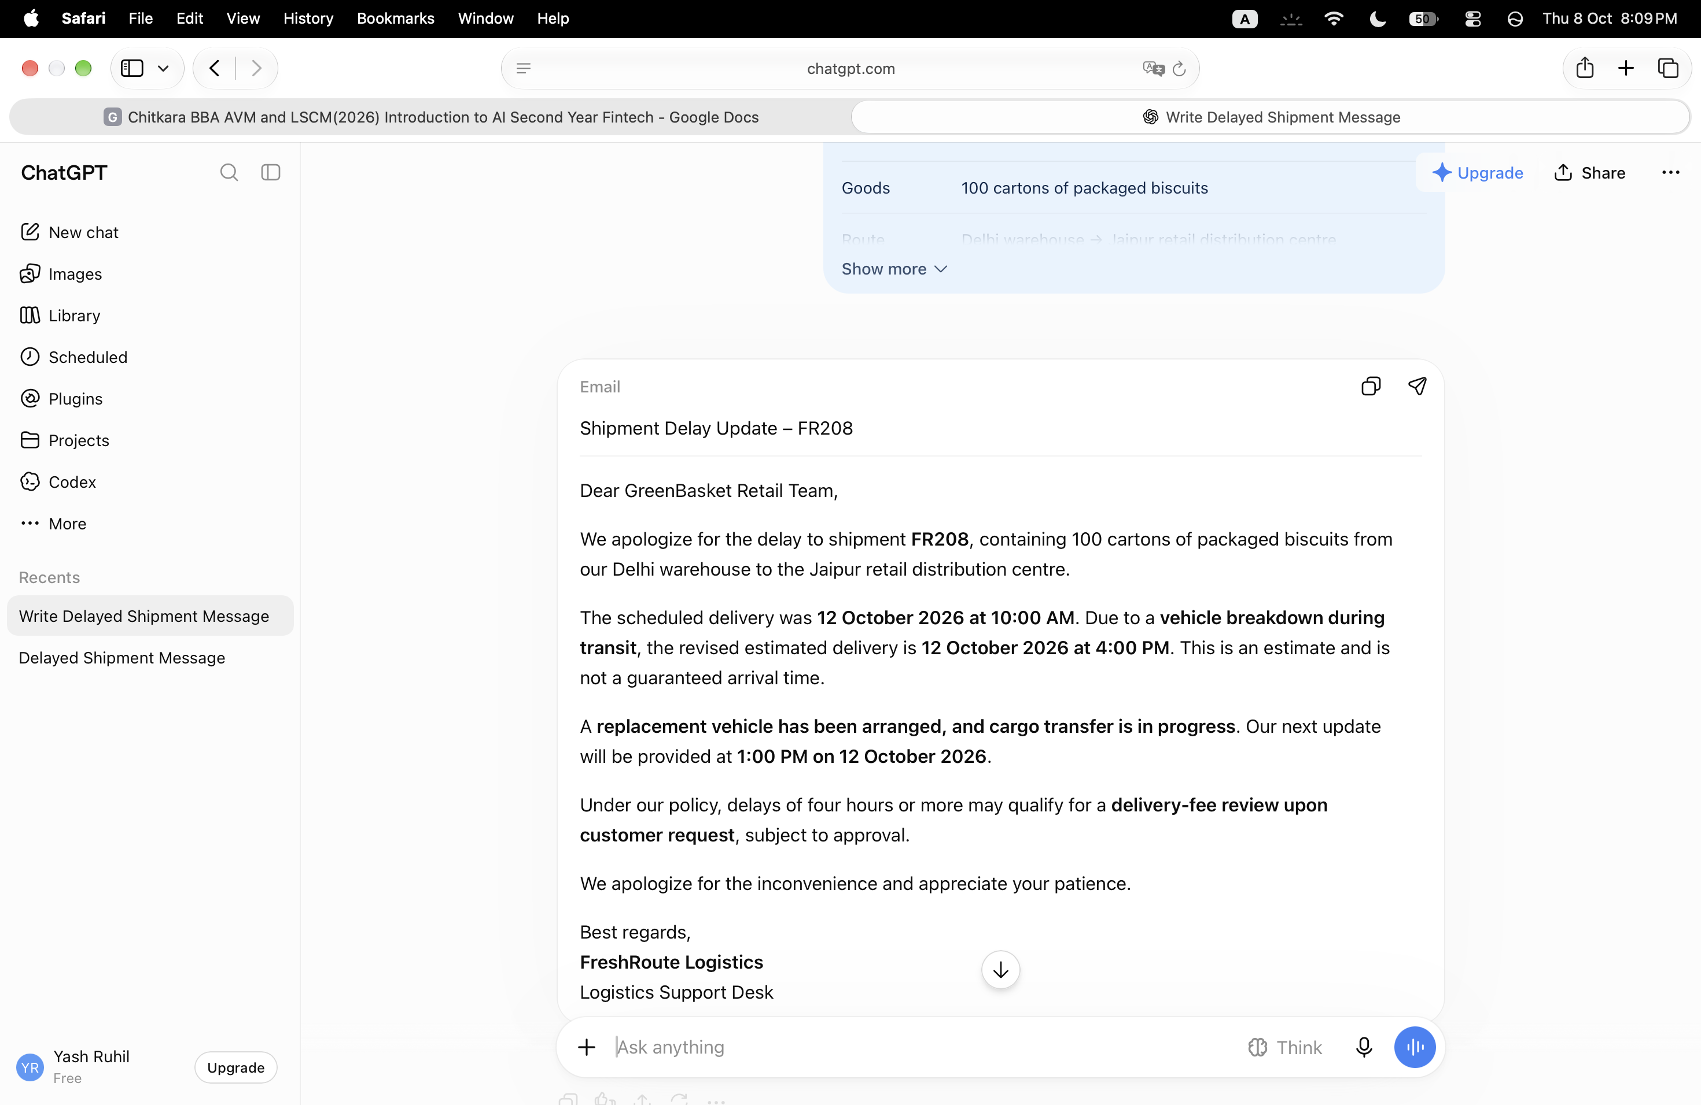
PROMPT USED-Using only the shipment information provided above, write a professional customer email within 120 words. Include a subject line, shipment ID, scheduled delivery, revised estimated delivery, delay reason, recovery action and next update. Briefly explain the delivery-fee review policy. Do not invent a refund amount, driver contact number, live location or cargo condition. Do not guarantee the estimated delivery time.
1.s the message more specific than Round 1?-Yes. It includes the shipment ID, quantity, route, delay reason, revised delivery time, replacement-vehicle status, and next update time.

2.Does it distinguish an estimated delivery from a guarantee?-Yes. It explicitly says the 4:00 PM delivery is an estimate and not a guaranteed arrival time.

3.Does it explain that a refund requires approval?-Partially.- It says a delivery-fee review is “subject to approval,” but it does **not explicitly say that a refund requires approval. Also, it refers to a delivery-fee review, not a refund.

ROUND 3-
PROMPT USED-Act as a logistics customer service executive at FreshRoute Logistics. Rewrite the previous email in a calm, respectful and accountable tone. Acknowledge that the delay may affect the customer’s planning. Preserve all supplied facts, stay within 120 words and do not add promises or unverified information.

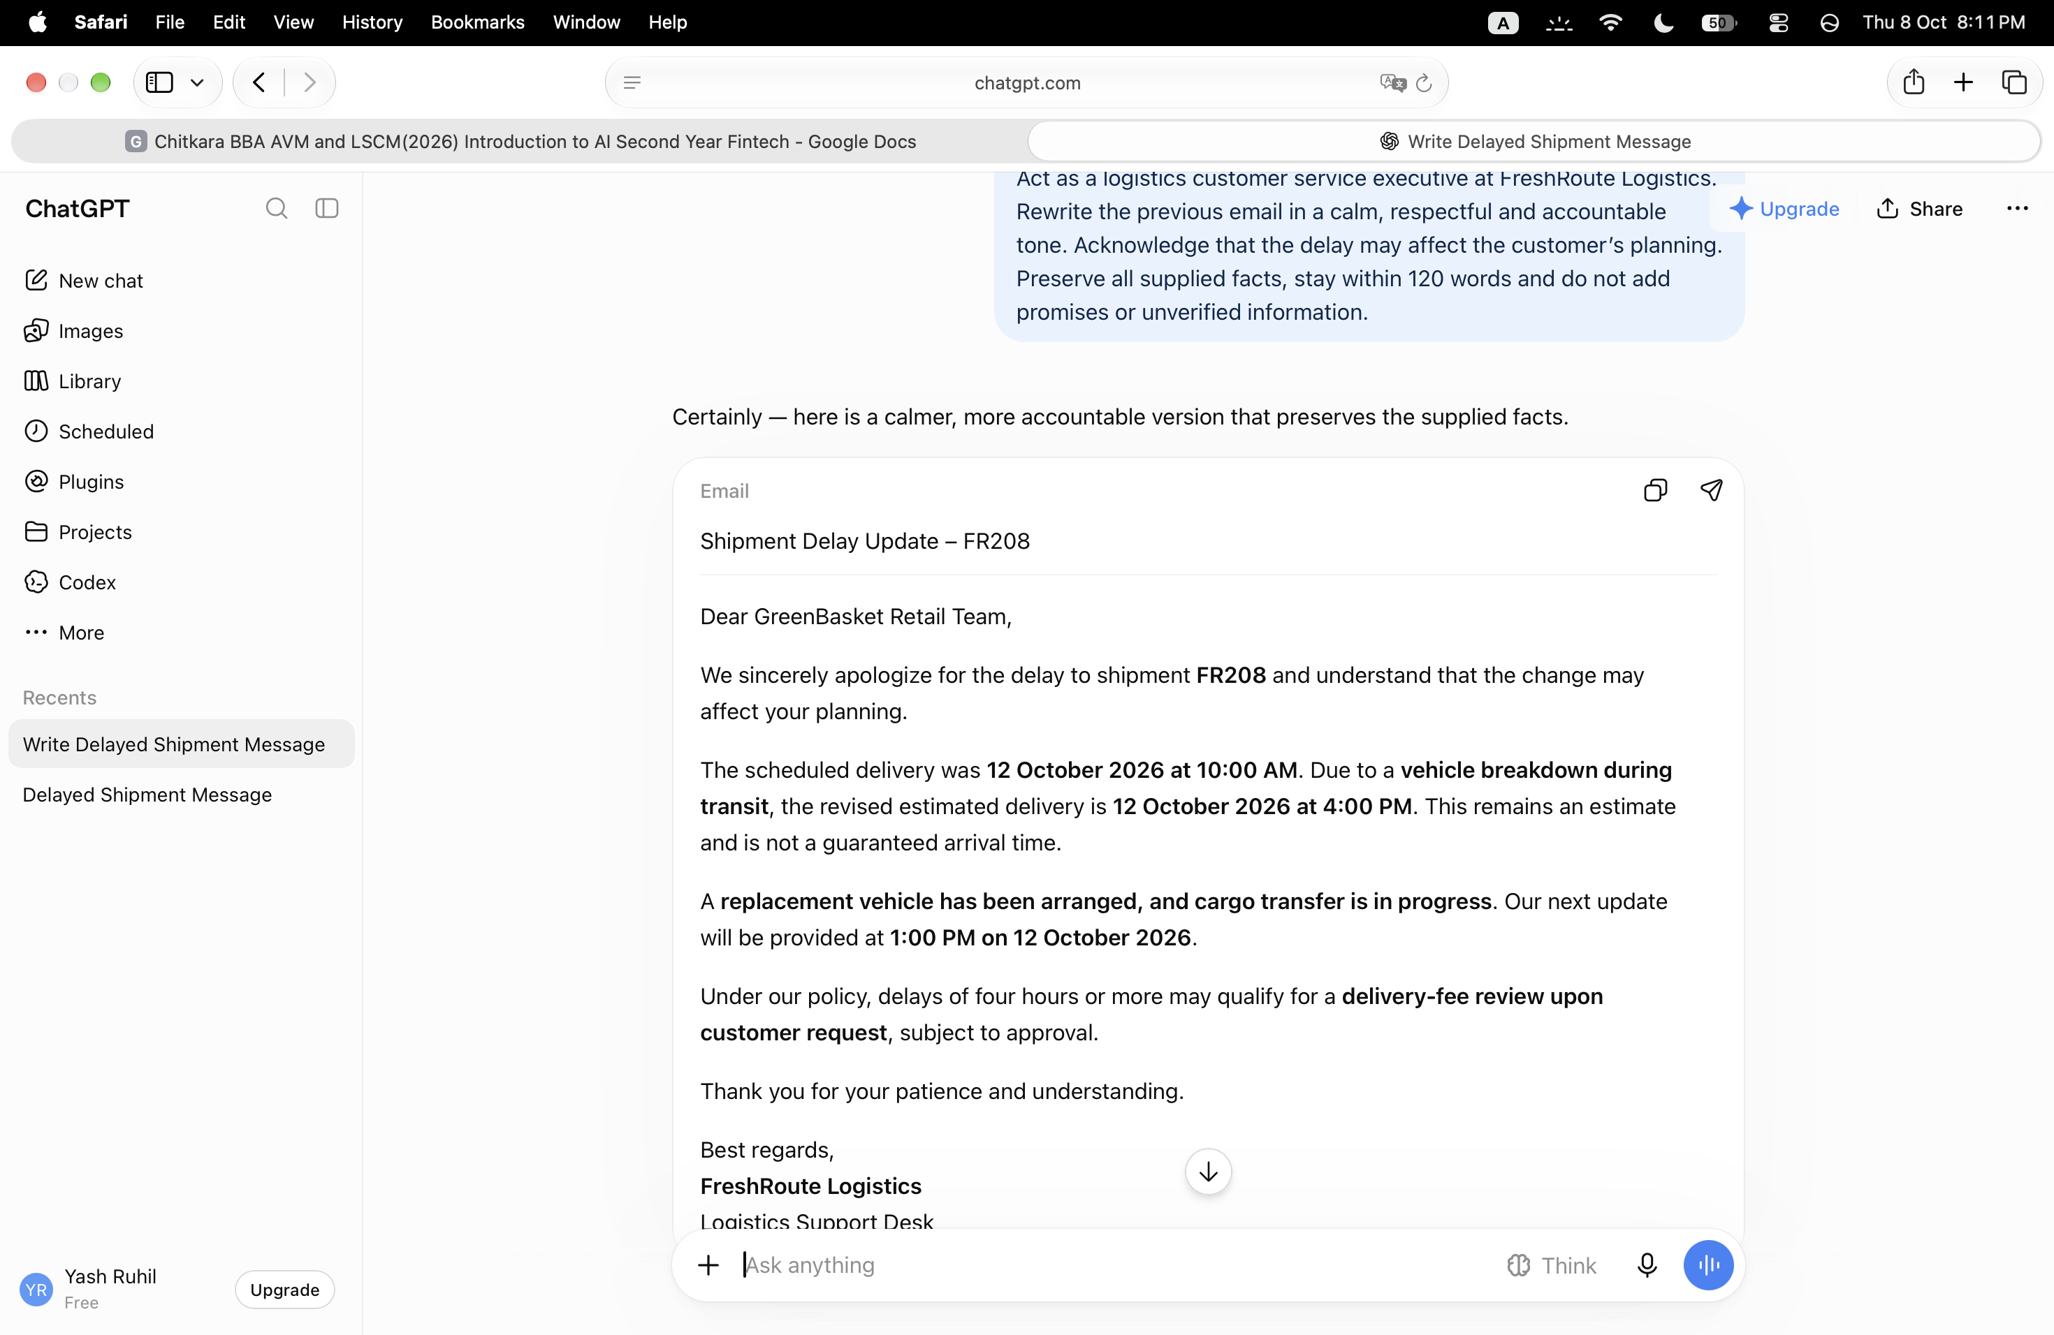
1.Does the response acknowledge the customer’s inconvenience?-Yes. It acknowledges that the delay may affect the customer’s planning and includes an apology.

2.Is the tone professional?-Yes. The tone is calm, respectful, and accountable, without being overly defensive or making unnecessary promises.

3.Did the change in role introduce any unsupported claim?-No. The role change to a logistics customer service executive did not introduce a new unsupported claim. The response preserves the supplied facts, including the vehicle breakdown, replacement vehicle, revised estimate, and delivery-fee review subject to approval.

ROUND 4-

PROMPT USED-Follow the concise question-and-answer style of these examples:
CUSTOMER- WHAT IS MY SHIPMENT REFRENCE

Response: “Your shipment reference is FR208.”
Customer: “When will I receive the next update?”
Response: “Your next update is scheduled for 12 October 2026 at 1:00 PM.”
Now answer these questions using only the supplied shipment information:
- Why is my shipment delayed?
- What is being done to recover the shipment?
- Will I automatically receive a refund?
- Can you confirm that all cartons are undamaged?
Keep each answer within two sentences. If information is unavailable, state that clearly and refer the customer to the logistics support desk. Do not invent details.

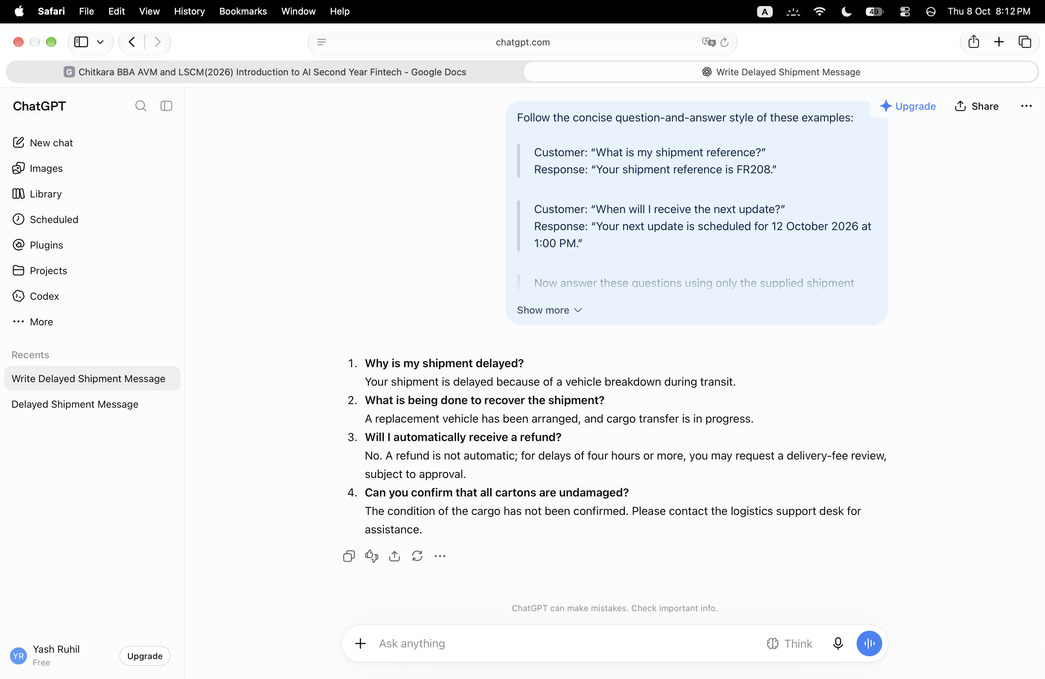

1.Does the AI follow the example format?- Yes. It uses a concise **question-and-answer format** matching the examples.

2.Does it distinguish fee review from an automatic refund?-Yes. It clearly states that a refund is **not automatic and that the customer may request a delivery-fee review, subject to approval.

3Does it avoid claiming that the cargo is undamaged?-Yes. It correctly states that the **condition of the cargo has not been confirmed, rather than making an unsupported claim.

ROUND 5-
PROMPT USED-Using only the supplied shipment facts and fictional policy, create a table with three columns: Customer Question, Answer Based on Supplied Information, and Missing Information or Approval Needed.
Answer these questions:
- When was delivery originally scheduled?
- What is the revised estimated delivery time?
- Why is the shipment delayed?
- What recovery action is underway?
- How much refund will I receive?
- Where is the vehicle currently located?
Write “Not provided” where information is unavailable. Write “None” in the final column when no additional information is needed to answer the question. Do not guess.
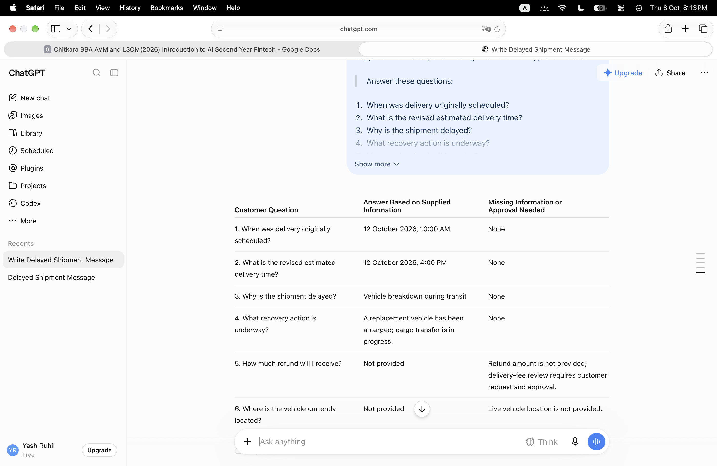
- Is the table easier to check than a paragraph? Yes. The table organizes each customer question, the available answer, and any missing information or approval requirements into clear columns.

- Are unknown details clearly identified? Yes. The refund amount and the vehicle’s current location are marked as not provided, with the missing information explained.

- Does the refund answer correctly explain the approval requirement? Yes. It states that the refund amount is not provided and that a delivery-fee review requires a customer request and approval. This correctly avoids promising an automatic refund.

ROUND 6-
PROMPT USED-
Using the supplied shipment information, create:
A. A customer SMS within 50 words, including shipment ID, revised estimated delivery and next update.
B. An internal briefing within 100 words for the warehouse coordination team, including shipment quantity, route, delay reason, recovery action and key unknowns requiring confirmation.
Label the two outputs clearly. Keep facts consistent. Do not invent a new recovery action, cargo condition or delivery guarantee.
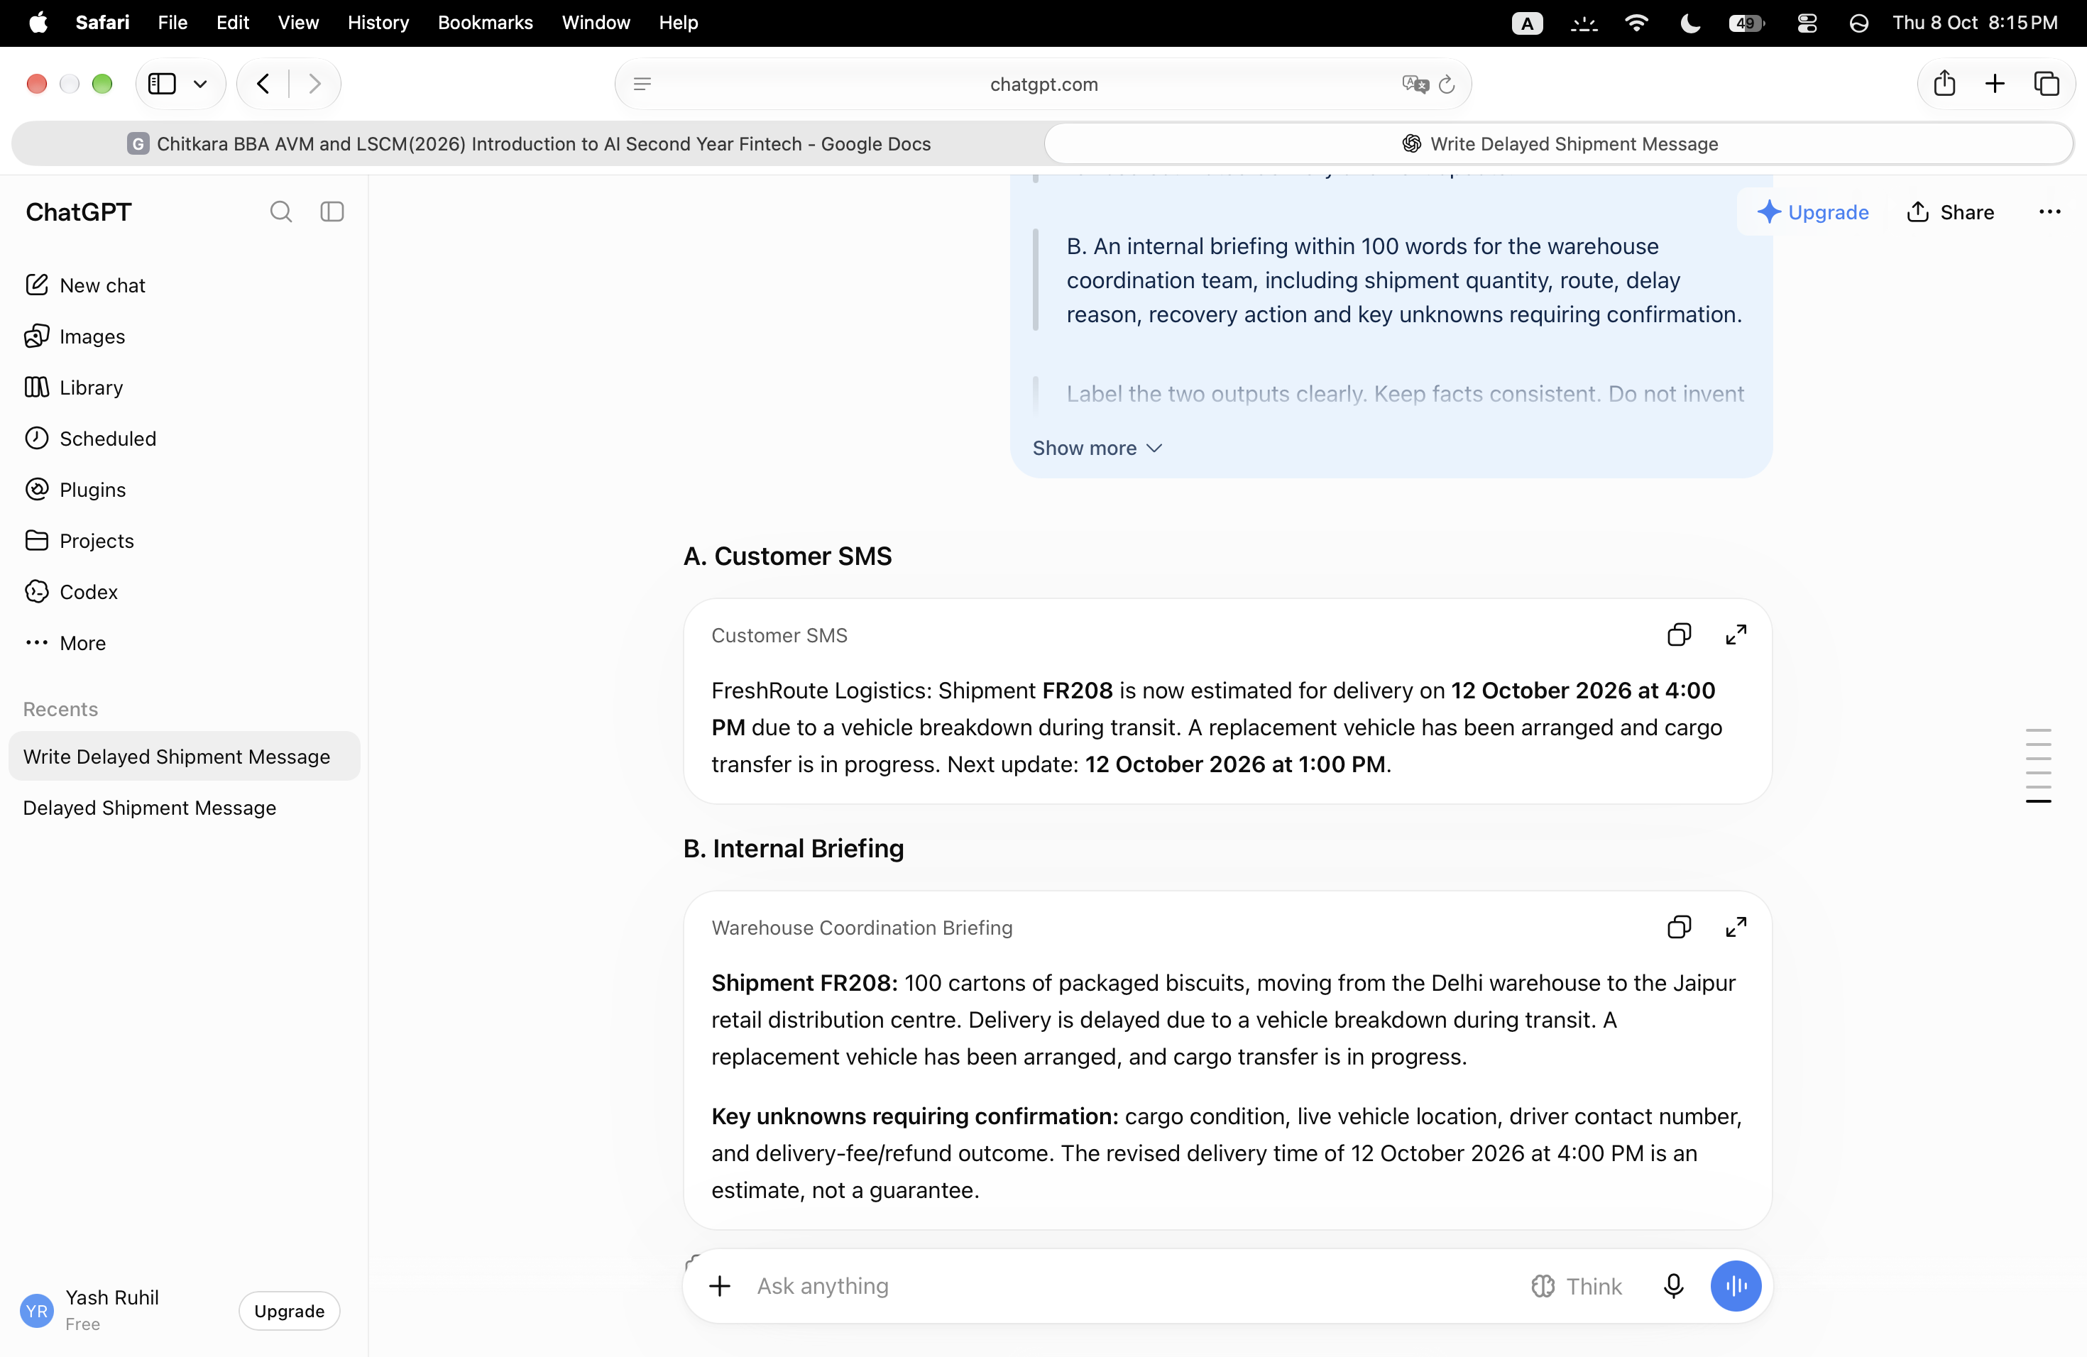

1.Is the customer SMS brief and understandable?- Yes. It communicates the shipment ID, delay reason, revised estimated delivery time, recovery action, and next update in a concise, customer-friendly message.

2.Does the internal briefing contain more operational detail? -Yes. It includes the shipment quantity, route, recovery action, and key unknowns requiring confirmation, such as cargo condition, vehicle location, driver contact number, and delivery-fee/refund outcome.
3.Are the shipment facts consistent across both outputs? -Yes. Both identify shipment FR208, the vehicle breakdown, the replacement vehicle and cargo transfer, and the estimated delivery of 12 October 2026 at 4:00 PM, with the next update at 1:00 PM stated in the SMS. The briefing correctly clarifies that the delivery time is an estimate, not a guarantee.

Live Change Challenge
Prompt used - The revised estimated delivery is now 6:00 PM on 12 October 2026. The next customer update is now 3:00 PM. All other supplied information remains unchanged. remove outdated timing.

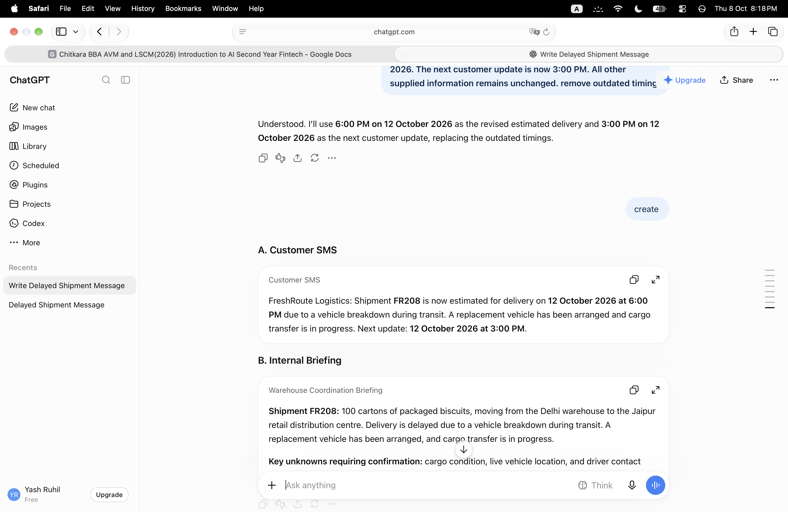

Explanation / Verification
I checked the updated email and SMS against the new information. The
revised estimated delivery was changed to 6:00 PM and the next customer
update was changed to 3:00 PM. I also checked that the outdated timings
were removed and that the delivery time was still presented as an estimate,
not a guarantee.

7. Manual Verification

Detail to  check | Correct information | Corre  ct in  final  outpu  t? | Correction  made, if  needed
Shipment  ID | FR208 | Yes | None
Revised  estimated  delivery | 12 October 2026, 6:00 PM | Yes | None
Next  update | 12 October 2026, 3:00 PM | Yes | None
Delay  reason, if  mentioned | Vehicle breakdown during  transit | Yes | None

Recovery  action, if  mentioned | Replacement vehicle  arranged; cargo transfer  in progress | Yes | None
Refund  policy, if  mentioned | Fee review may be  requested; refund requires  approval | Yes | None
Cargo  condition | Not confirmed | Yes | None
Delivery  wording | Estimated arrival; no  guarantee | Yes | None

8. Reflection
1. Which prompting strategy produced the most useful output, and why?
Context and constraints produced the most useful output because the AI had
the complete shipment information and clear instructions about what it could
and could not include. This made the response more accurate and reliable.
2. How did adding context change the initial response?
Adding context changed the response from a generic delay message into a
specific customer communication. It included the shipment ID, delivery
timings, delay reason, recovery action and next update.
3. What unsupported claim did you identify, or what potential error did you check
for?
I checked for unsupported information such as a refund amount, vehicle
location, driver contact number and cargo condition. I made sure the AI did
not present the estimated delivery time as a guarantee.
4. How did the customer message differ from the internal briefing?
The customer message was short, clear and focused on delivery information
and the next update. The internal briefing included more operational details
such as shipment quantity, route, recovery action and information that still
needed confirmation.
5. What must a human verify before sending these messages?
A human should verify the shipment ID, delivery timings, delay reason,
recovery action and company policy before sending the messages. They
should also check that the AI has not invented information or made promises
that the company cannot guarantee.
9. AI-Use Declaration
AI-Use Declaration
“I used ChatGPT to generate and refine draft communication. I checked the
outputs against the supplied fictional facts and policy. The observations,
verification and reflection are my own work.”

